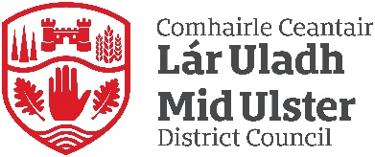
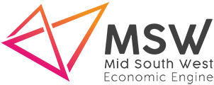
Mid South West Growth Deal
The Mid South West Growth Deal is a collaboration between Armagh City, Banbridge and Craigavon; Fermanagh and Omagh and Mid Ulster which seeks to supercharge economic growth within the area.
The geographical position of the region plays a significant part in its success, stretching along the border corridor where it enjoys a unique natural co-dependency with the Republic of Ireland in trade and investment, tourism, and labour. The region itself makes up half of Northern Ireland’s landmass and is home to a quarter of the province’s population and a quarter of its business. Mid South West provides 214,000 workplace jobs. 90% of which are taken up by local people and generates one fifth of Northern Ireland’s entire GVA.
Manufacturing is the top employment sector within the Mid South West and a study by Ulster University Economic Policy Centre (UUEPC) highlighted that our region accounts for two fifths (39%) of NI’s manufacturing employment and a quarter (23%) of its manufacturing GVA.
The Growth Deal will provide opportunities across the three Council areas which will seek to promote innovation, infrastructure, and tourism.

