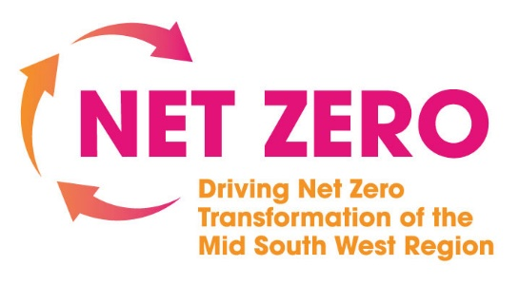
The Climate Change Act (NI) 2022 has a target of an at least 100% reduction in net zero greenhouse gas (GHG) emissions by 2050 (i.e., net zero emissions by 2050) for Northern Ireland compared to the baseline, along with interim targets including an at least 48% reduction in net emissions by 2030.
The ‘Driving the Net Zero Transformation of the Mid South West Region’ Programme seeks to support micro, small and medium enterprises operating in key sectors in the MSW Region with their Net Zero ambitions. Funded by Innovate UK’s Fast Followers, the programme will support businesses from these key sectors through engagement, awareness raising and the provision of access to external expertise to develop knowledge, skills and capacity in relation to net zero. Support will be delivered throughout 2024 and early 2025 via a series of webinars, breakfast seminars and a regional conference.
For businesses that operate within the following sectors, bespoke support will be provided to establish Net Zero baselines and develop action plans:
- Advanced Manufacturing and Engineering
- Agri-Food
- Construction
If you are interested in what support your business can receive, please register your interest on the Mid South West Region website https://midsouthwestregion.org/net-zero-transformation/

